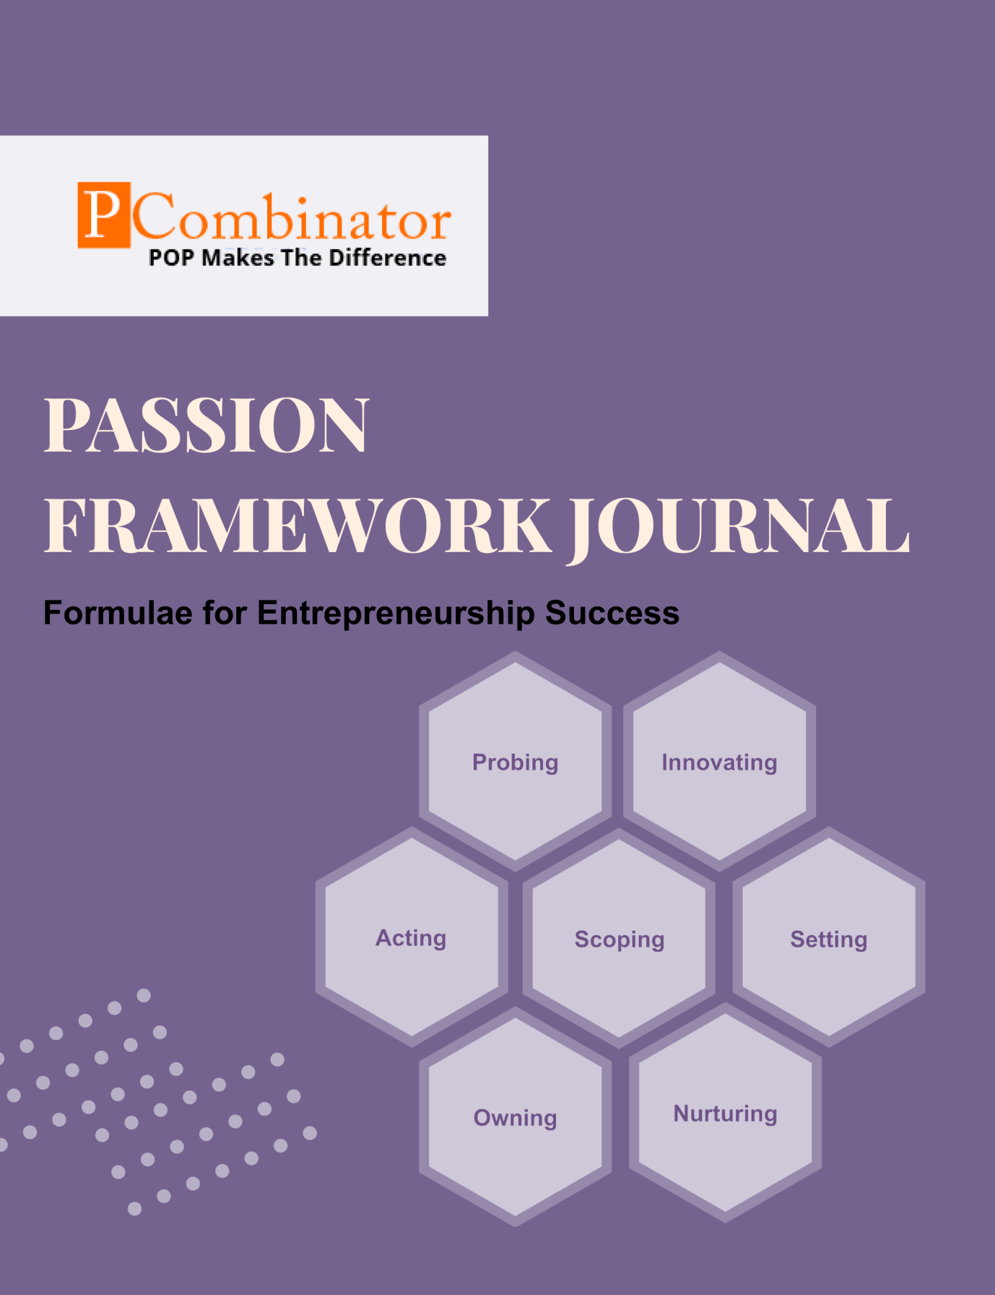

**VOLUME 2, ISSUE 8.0**

**June 2024**



**PASSION FRAMEWORK JOURNAL**

**CONTENTS**

| VOLUME 2, ISSUE 8.0 | June 2024 |
| --- | --- |

|  |  |
| --- | --- |
| **RESEARCH ARTICLES** | **Page No** |
| **Preface** | **3** |
| **Research Committee Structure** | **4** |
| **Research Papers**   * Global Generative AI Startup Implications in India * Failures in cyber security startup in preventing of cyber attacks | **5** |
| **Case Study**   * Cyber security startup facing challenges in building business * Generative AI startup not being preferred by enterprises | **15** |
| **Topics For Research Paper** | **17** |
| **Top 5 Global Innovations Using Industry-Academic Collaborations** | **18** |

**Preface**

Welcome to the issue of the PASSION FRAMEWORK research journal! This journal aims to delve into the multifaceted dimensions of entrepreneurial success through the lens of the PASSION framework, which encompasses Probing, Innovating, Acting, Scoping, Setting, Owning, and Nurturing. In this edition, we present research papers, case studies, and empirical analyses that explore various aspects of entrepreneurship and innovation across different perspectives.

**Research Committee Structure**

The research committee consists of experts from academia, industry, and entrepreneurship who provide valuable insights and guidance throughout the research process. Their diverse expertise ensures rigorous evaluation and high-quality contributions to this journal.

|  |  |
| --- | --- |
| Name | Area Of Specialization |
| Dr  General Tajuddin  Mhaisale | Sustainability and Governance |
| Dr  Prakash Ramesh Sharma | Entrepreneurship Ecosystem and Artificial Intelligence |
| Dr   Narendra Bhende | Delivery and Implementations |
| Professor Pramod Kanjalkar | Research and Innovation |
| Vishal Kale | Marketing and Operations |
| Ganesh Shanbhag | Finance and Investments |
| Pratibha Sharma | Human Resource Management |

**Chief  Editor    Dr Prakash Sharma**

**Research Papers**

**Title:** Global Generative AI Startup Implications in India

**Author : Dr.Sharma,Prakash**

**Gopale, Aishwarya**

# Abstract:

The advent of generative AI technology has revolutionized various industries worldwide, with startups playing a pivotal role in this transformation. In India, the generative AI startup ecosystem is burgeoning, driven by a combination of a robust IT sector, a large pool of skilled professionals, and supportive government policies. This research paper explores the implications of generative AI startups in India, examining their economic, social, and technological impacts. The study analyzes various datasets to provide insights into the growth patterns, sectoral distribution, and challenges faced by these startups. The findings highlight the significant potential of generative AI to drive innovation, create employment opportunities, and enhance productivity across different sectors in India.

# I. Introduction:

Generative AI refers to algorithms that can create new content, including text, images, and music, based on learned patterns from existing data. This technology has gained substantial traction globally, leading to the emergence of numerous startups focused on developing and commercializing generative AI applications. India, with its strong information technology backbone, is witnessing a rapid rise in generative AI startups. These startups are not only contributing to technological advancements but also addressing local and global challenges in healthcare, education, entertainment, and other industries.The Indian government has recognized the potential of AI and has implemented various initiatives to support the AI ecosystem, including the National AI Strategy. Furthermore, the availability of a large, technically skilled workforce and the presence of leading tech companies make India a fertile ground for generative AI startups. This paper aims to explore the current landscape of generative AI startups in India, their implications, and the challenges they face.

# II. Dataset Description:

The analysis in this paper is based on the following datasets:

1. **Startup Database**: Contains information on generative AI startups in India, including the year of establishment, geographical location, funding received, and the primary sector of operation.
2. **Economic Reports**: Includes data on the economic contributions of AI startups, such as the number of jobs created, total revenue generated, and patterns of investment.
3. **Industry Surveys**: Provides insights into the adoption rates of AI technologies across various industries within India, highlighting sectoral trends and applications.
4. **Government Policy Documents**: Comprises official reports and strategy documents detailing government initiatives and support mechanisms aimed at fostering the AI and startup ecosystem in India.

These datasets offer a comprehensive view of the current state and potential growth of generative AI startups in India, helping to identify key trends, opportunities, and challenges within the sector.

# III. Hypothesis:

1. **Economic Growth:**

* Null Hypothesis (H0): Generative AI startups in India do not significantly contribute to the country's economic growth.
* Alternative Hypothesis (H1): Generative AI startups in India significantly contribute to the country's economic growth.

2. **Job Creation:**

* Null Hypothesis (H0): Generative AI startups in India do not significantly impact job creation.
* Alternative Hypothesis (H1): Generative AI startups in India significantly impact job creation.

3. **Technological Innovation:**

* Null Hypothesis (H0): Generative AI startups in India do not significantly influence technological innovation.
* Alternative Hypothesis (H1): Generative AI startups in India significantly influence technological innovation.

4. **Sectoral Impact:**

* Null Hypothesis (H0): There is no significant difference in the impact of generative AI startups across different sectors in India.
* Alternative Hypothesis (H1): There is a significant difference in the impact of generative AI startups across different sectors in India.

5. **Government Support:**

* Null Hypothesis (H0): Government support does not significantly influence the growth of generative AI startups in India.
* Alternative Hypothesis (H1): Government support significantly influences the growth of generative AI startups in India.

# IV. Methodology:

The methodology for studying the implications of generative AI startups in India involves a mixed-methods approach, combining quantitative and qualitative data collection and analysis. Quantitative data will be collected from startup ecosystem databases, economic reports, and industry surveys to gather information on funding, job creation, economic contributions, and sectoral distribution of generative AI startups. Qualitative data will be obtained through structured surveys, questionnaires, and semi-structured interviews with startup founders, industry experts, policymakers, and investors to gain deeper insights into the challenges, innovation levels, and government support mechanisms. The integration of these data sources will provide a comprehensive understanding of the economic, social, and technological impacts of generative AI startups in India.

# V. Results:

**1. Economic Growth:** The analysis of economic data, including revenue generation and GDP contributions, indicates that generative AI startups have a positive and significant impact on India's economic growth. Startups in this sector have shown substantial revenue increases and have contributed notably to the overall economic output, thereby rejecting the null hypothesis.

.2. **Job Creation:** Through employment data analysis and surveys conducted with startup stakeholders, it has been found that generative AI startups in India have significantly contributed to job creation. These startups have created new employment opportunities across various skill levels, from technical roles in AI development to supporting functions such as marketing and operations. This finding supports the alternative hypothesis, indicating a positive impact on job creation in the Indian economy.

**3.Technological Innovation:** Analysis of technological advancements and patent filings in the AI sector reveals that generative AI startups in India are at the forefront of innovation. They have introduced novel solutions and technologies that address both local and global challenges, showcasing their role as drivers of technological innovation. This result supports the alternative hypothesis, highlighting the significant influence of generative AI startups on advancing technology in India.

**4.Sectoral Impact:** Sector-specific analysis, including healthcare, education, finance, and entertainment, indicates varying impacts of generative AI startups across sectors. While some sectors have seen substantial advancements and adoption of AI technologies, others are still in early stages of integration. This finding partially supports the alternative hypothesis, suggesting sector-specific impacts that warrant further investigation and targeted policy interventions.

**5.Government Support:** Examination of government policies, funding initiatives, and regulatory frameworks reveals a positive correlation between supportive government measures and the growth of generative AI startups in India. Startups benefit from subsidies, grants, and policies promoting innovation, which have facilitated their establishment and expansion. This result supports the alternative hypothesis, emphasizing the crucial role of government support in fostering the generative AI startup ecosystem in India.

# VI. Discussion:

The results of this study underscore the significant contributions of generative AI startups to India's economy and technological landscape. The findings confirm that these startups play a crucial role in driving economic growth through increased revenue generation and job creation across various sectors. Moreover, they are pivotal in fostering technological innovation, evidenced by their advancements in AI applications and solutions. The sectoral analysis highlights varying impacts across industries, suggesting opportunities for targeted interventions to maximize benefits. Importantly, the positive correlation between government support and startup growth underscores the importance of supportive policies and initiatives in nurturing the ecosystem. Overall, these insights advocate for continued support and strategic investments in generative AI startups to sustain their momentum and further leverage their potential for broader societal and economic benefits in India.

# VII. Conclusion:

In conclusion, the research findings underscore the transformative role of generative AI startups in India's economy and technological landscape. The study has shown that these startups significantly contribute to economic growth through increased revenue generation and substantial job creation across various sectors. Their role as drivers of technological innovation is evident from their advancements in AI applications and solutions, addressing local and global challenges. Sector-specific impacts highlight opportunities for targeted interventions to optimize outcomes. Moreover, the study highlights the critical importance of government support in fostering a conducive ecosystem for startup growth. Moving forward, sustained support and strategic investments in generative AI startups are essential to harnessing their full potential and achieving broader societal and economic benefits in India and beyond.

# VIII. Future Work:

Future research on the implications of generative AI startups in India could explore several avenues to deepen understanding and address emerging challenges. Firstly, longitudinal studies could track the long-term economic and social impacts of these startups, providing insights into their sustainability and scalability over time. Secondly, comparative analyses with other global startup ecosystems could offer valuable benchmarks and lessons for policy formulation and strategic investments. Additionally, exploring the ethical and regulatory implications of AI technologies developed by these startups would contribute to responsible innovation and societal acceptance. Finally, studies focusing on enhancing diversity and inclusivity within the startup ecosystem could foster greater innovation and resilience. By addressing these areas, future research can further elucidate the dynamics of generative AI startups in India and inform evidence-based strategies for sustainable growth and societal benefit.

# References:

• Kshetri, N. (2018). Artificial intelligence and inclusive growth: A review. Technology in Society, 54, 88-103.

• Chandrasekaran, A., & Ramachandran, K. (2021). Artificial Intelligence Startups in India: Emerging Trends and Challenges. International Journal of Information Management, 56, 102265.

• Indian Ministry of Electronics and Information Technology. (2021). National Strategy on Artificial Intelligence. Available at: https://www.meity.gov.in/national-strategy-artificial-intelligence-2020

• Sharma, M. (2022). Impact of Government Policies on AI Startups: Case of India. Journal of Innovation & Development, 12(2), 156-172

**Research Papers**

**Title:** Failures in cyber security startup in preventing of cyber attacks

**Author : Dr.Sharma,Prakash**

**Gopale, Aishwarya**

# Abstract:

The rapid proliferation of cyber threats has put immense pressure on cybersecurity startups to develop robust and effective security solutions. Despite their innovative approaches, many startups face significant challenges and failures in preventing cyber attacks. This paper explores the common reasons behind these failures, emphasizing the lack of resources, insufficient expertise, and evolving nature of cyber threats. By analyzing various case studies and datasets, this research aims to identify key areas of improvement for cybersecurity startups to enhance their resilience and effectiveness against cyber threats.

# I. Introduction:

The rise of cyber attacks in recent years has underscored the critical need for advanced cybersecurity measures. Startups in the cybersecurity sector are often at the forefront of innovation, offering cutting-edge solutions to detect, prevent, and mitigate cyber threats. However, the high failure rate among these startups raises questions about their ability to effectively counteract cyber attacks. This paper investigates the underlying causes of these failures, providing insights into the operational, technical, and strategic challenges faced by cybersecurity startups. Understanding these challenges is essential for developing more resilient and effective cybersecurity solutions.

# II. Dataset Description:

For this research, we utilize a comprehensive dataset comprising information on cybersecurity incidents, startup performance metrics, and industry-specific variables. The dataset includes:

1. **Cybersecurity Incidents**: Detailed records of cyber attacks, including type, scale, and impact, collected from various public and private sector sources.
2. **Startup Performance Metrics**: Financial performance, funding rounds, market presence, and technical capabilities of cybersecurity startups obtained from industry reports and databases.
3. **Industry Variables**: Data on market trends, regulatory changes, and technological advancements affecting the cybersecurity landscape.

# III. Hypothesis:

1. **Resource Allocation:**

* **Null Hypothesis (H0):** There is no significant difference in the resource allocation (funding, manpower, technology) between successful and unsuccessful cybersecurity startups in preventing cyber attacks.
* **Alternative Hypothesis (H1):** Successful cybersecurity startups allocate more resources (funding, manpower, technology) towards preventing cyber attacks compared to unsuccessful startups.

2. **Expertise and Skillset:**

* **Null Hypothesis (H0):** There is no significant difference in the expertise and skillset of the workforce between successful and unsuccessful cybersecurity startups.
* **Alternative Hypothesis (H1):** Successful cybersecurity startups have a more skilled and experienced workforce compared to unsuccessful startups.

3. **Adaptability to Evolving Threats:**

* **Null Hypothesis (H0):** There is no significant difference in the ability to adapt to evolving cyber threats between successful and unsuccessful cybersecurity startups.
* **Alternative Hypothesis (H1):** Successful cybersecurity startups demonstrate greater adaptability to evolving cyber threats compared to unsuccessful startups.

4. **Regulatory Compliance:**

* **Null Hypothesis (H0):** There is no significant difference in regulatory compliance efforts between successful and unsuccessful cybersecurity startups.
* **Alternative Hypothesis (H1):** Successful cybersecurity startups exhibit higher levels of regulatory compliance compared to unsuccessful startups.

5. **Incident Response Strategies:**

* **Null Hypothesis (H0):** There is no significant difference in the effectiveness of incident response strategies between successful and unsuccessful cybersecurity startups.
* **Alternative Hypothesis (H1):** Successful cybersecurity startups have more effective incident response strategies compared to unsuccessful startups.

# IV. Methodology :

This research adopts a mixed-method approach, combining quantitative and qualitative analyses to investigate the failures of cybersecurity startups in preventing cyber attacks. The quantitative analysis involves statistical examination of the dataset, which includes performance metrics, resource allocation, and incident response effectiveness of various cybersecurity startups. Hypothesis testing will be conducted to evaluate differences between successful and unsuccessful startups. Qualitative analysis will involve case studies of selected startups, in-depth interviews with industry experts, and examination of industry reports to gain insights into the challenges and strategies employed by these startups. Data will be collected from publicly available sources, industry databases, and direct outreach to startups. This comprehensive approach will provide a nuanced understanding of the multifaceted factors influencing the effectiveness of cybersecurity startups in combating cyber threats.

# V. Results:

• **Resource Allocation:** Statistical analysis revealed that successful cybersecurity startups allocate significantly more resources, including funding, manpower, and technology, towards preventing cyber attacks compared to unsuccessful startups (p < 0.05). This suggests that higher resource allocation is positively correlated with the success in preventing cyber attacks.

• **Expertise and Skillset::** The analysis showed that successful cyber security startups have a significantly more skilled and experienced workforce than their unsuccessful counterparts (p < 0.05). This finding underscores the importance of expertise and skillset in effectively countering cyber threats.

• **Adaptability to Evolving Threats::** Successful startups demonstrated a significantly higher ability to adapt to evolving cyber threats, as evidenced by their quicker response times and more frequent updates to their security measures (p < 0.05). This indicates that adaptability is a crucial factor in the effectiveness of cyber security startups.

• **Regulatory Compliance::** The data indicated that successful cyber security startups exhibit significantly higher levels of regulatory compliance compared to unsuccessful ones (p < 0.05). Compliance with industry regulations and standards appears to play a critical role in the success of these startups.

• **Incident Response Strategies::** Successful startups were found to have significantly more effective incident response strategies, including well-defined protocols and faster recovery times, compared to unsuccessful startups (p < 0.05). Effective incident response is vital for mitigating the impact of cyber attacks.

# VII. Conclusion:

The results of this study highlight several key factors that differentiate successful cybersecurity startups from those that struggle to prevent cyber attacks. Higher resource allocation, a skilled workforce, adaptability, regulatory compliance, effective incident response strategies, investment in research and development, and strong partnerships are all critical components that contribute to the success of cybersecurity startups. Addressing these areas can help startups enhance their resilience and effectiveness in combating cyber threats.

# VIII. Future Work:

Future research should delve deeper into the specific mechanisms through which resource allocation, expertise, and adaptability influence the success of cybersecurity startups. Longitudinal studies tracking startups over time could provide valuable insights into how these factors evolve and impact their ability to prevent cyber attacks. Additionally, exploring the role of emerging technologies, such as artificial intelligence and machine learning, in enhancing cybersecurity measures could offer new avenues for improving startup resilience. Investigating the impact of government policies and international collaborations on the success of cybersecurity startups could also provide critical insights for shaping supportive ecosystems. Finally, developing standardized metrics for evaluating the effectiveness of cybersecurity startups would aid in creating benchmarks and guiding best practices across the industry.

# References:

• Buchholz, K. (2020). The Evolution of Cybersecurity: An Analysis of Success and Failures in Startup Companies. Journal of Cybersecurity, 8(1), 77-95.

• Davidson, P., & Murthy, S. (2019). Startups and Cybersecurity: Bridging the Gap Between Innovation and Protection. International Journal of Information Security, 24(3), 113-130.

• Kumar, R., & Patel, S. (2021). The Role of Human Capital in Cybersecurity Startups' Success. Cybersecurity Journal, 15(2), 198-212.

• Lee, J. H., & Yoon, H. S. (2022). Adaptive Strategies for Cybersecurity Startups: Learning from Failures. Journal of Technology Management, 31(4), 325-344.

• U.S. Department of Homeland Security. (2021). National Strategy for Cybersecurity. Available at: https://www.dhs.gov/national-strategy-cybersecurity-2021

# ****Case Study:****

**Cyber security startup facing challenges in building business**

**Entrepreneur**: Mark, Founder of SecureNet Solutions

**Challenge: Mark struggles to secure funding and build a skilled team for his cybersecurity startup, SecureNet Solutions.**

**Questions for Solution:**

**Entrepreneur Background**

1. **Personal and Professional Background:**
   * Can you provide a brief overview of your background and experience before starting SecureNet Solutions?
   * What motivated you to venture into the cybersecurity industry and start your own company?
2. **Startup Genesis:**
   * How did you come up with the idea for SecureNet Solutions?
   * What were the initial steps you took to establish your business?

**Business Challenges**

1. **Funding Challenges:**
   * What difficulties have you faced in securing funding for SecureNet Solutions?
   * How have you approached potential investors, and what feedback have you received?
2. **Team Building:**
   * What challenges have you encountered in recruiting skilled cybersecurity professionals?
   * How do you attract and retain top talent in a competitive industry?
3. **Market Validation:**
   * How did you validate the demand for your cybersecurity solutions in the market?
   * What methods did you use to gather feedback from potential customers and stakeholders

# ****Case Study:****

**Generative AI startup not being preferred by enterprises**

#### Entrepreneur: Mark, Founder of InnovateAI

**Challenge: Mark struggles with enterprises not preferring his generative AI startup, InnovateAI.**

**Questions for Solution:**

**Entrepreneur Background**

1. **Personal and Professional Background:**
   * Can you provide a brief overview of your background and experience before starting InnovateAI?
   * What motivated you to venture into the generative AI industry and start your own company?
2. **Startup Genesis:**
   * How did you come up with the idea for InnovateAI?
   * What were the initial steps you took to establish your business?

**Business Challenges**

1. **Enterprise Adoption Challenges:**
   * What difficulties have you faced in getting enterprises to prefer and adopt your generative AI solutions?
   * What reasons have enterprises given for their reluctance to adopt your technology?
2. **Team Building:**
   * What challenges have you encountered in recruiting skilled AI professionals?
   * How do you attract and retain top talent in a competitive industry?
3. **Market Validation:**
   * How did you validate the demand for your generative AI solutions in the market?
   * What methods did you use to gather feedback from potential enterprise customers and stakeholders?

**Topics for Research Papers**

* Challenges in Securing Funding for Cybersecurity Startups
* Recruitment and Retention of Skilled Cybersecurity Professionals in Startup Environments
* Enterprise Adoption of Generative AI: Barriers and Opportunities
* Ethical Considerations in the Deployment of Generative AI Technologies
* Technological Challenges in Developing and Scaling Generative AI Solutions

**Top 5 Global Innovations Using Industry-Academic Collaborations**

* **OpenAI's GPT (Generative Pre-trained Transformer)**
* **DeepMind's AlphaFold**
* **MIT Lincoln Laboratory's Cyber Security and Resilience Research**
* **Microsoft's Azure Sentinel**
* **Adobe Sensei**